2000_PTR Enrollment initiated by CE - New Move in
Single Electric Residential
Contract No. 4017423964
Material No. 88000104
Serial No. 20003653
Equipment No. 100004737365
Contract Account. 100060315767
Functional Location. 6001373962

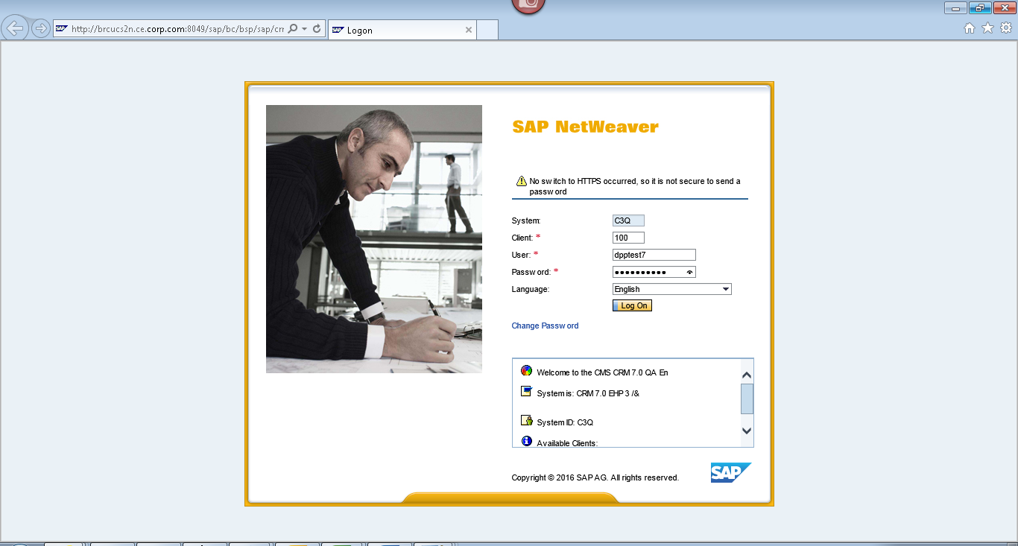
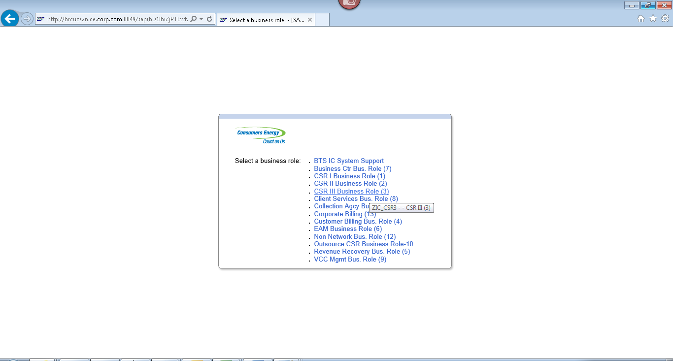
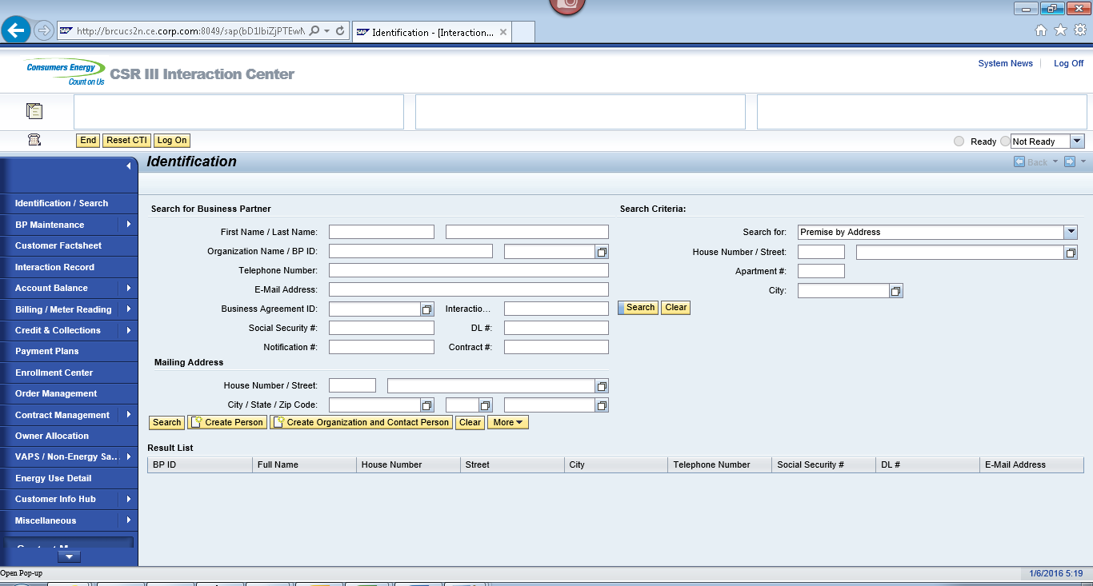
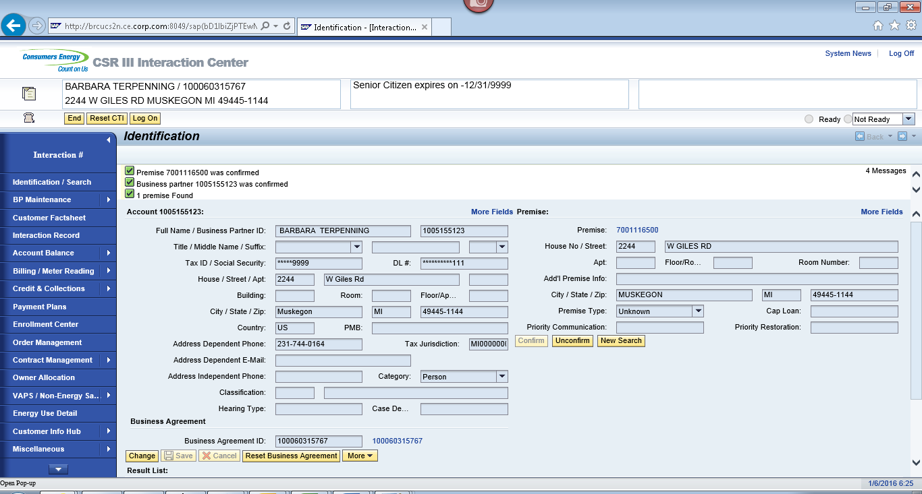
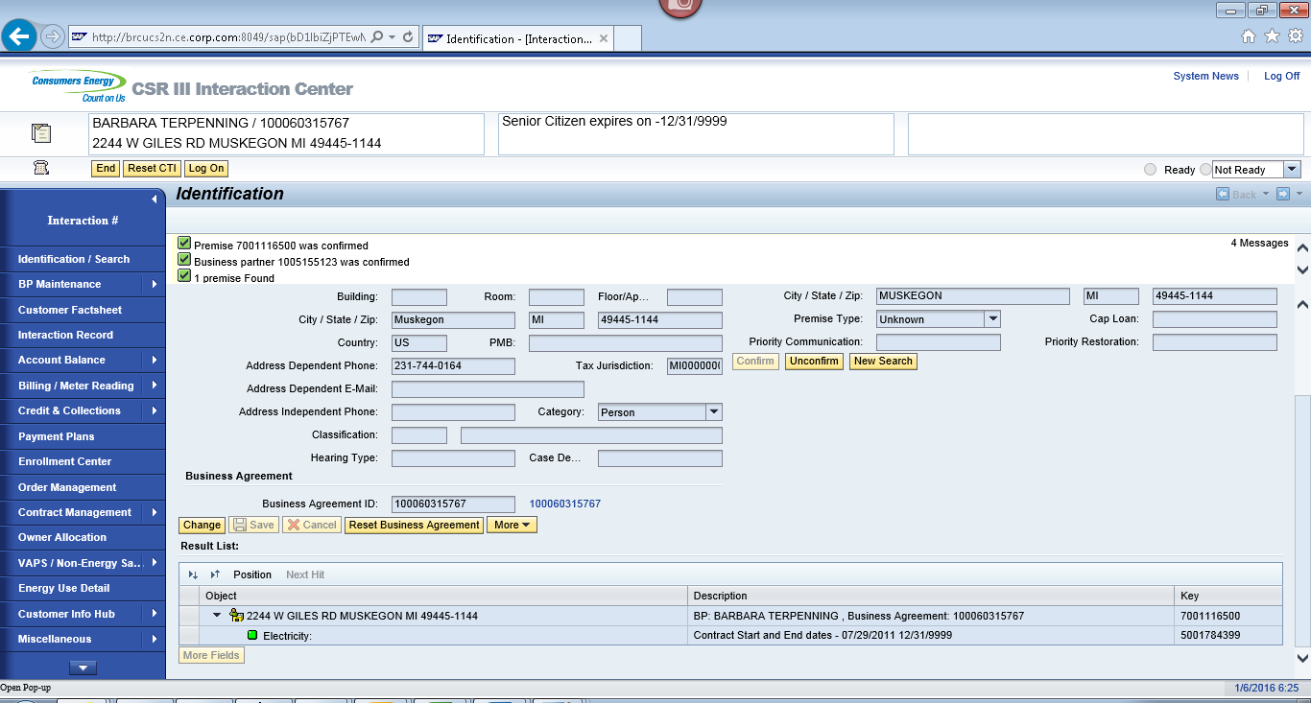
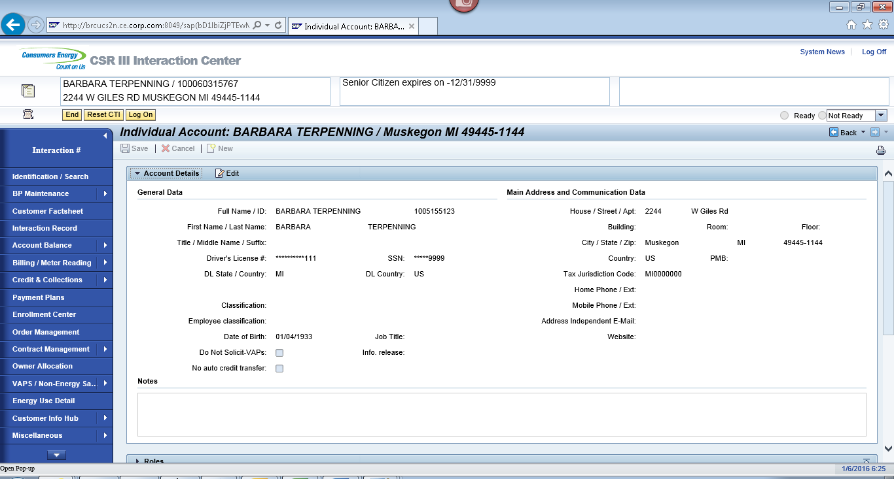
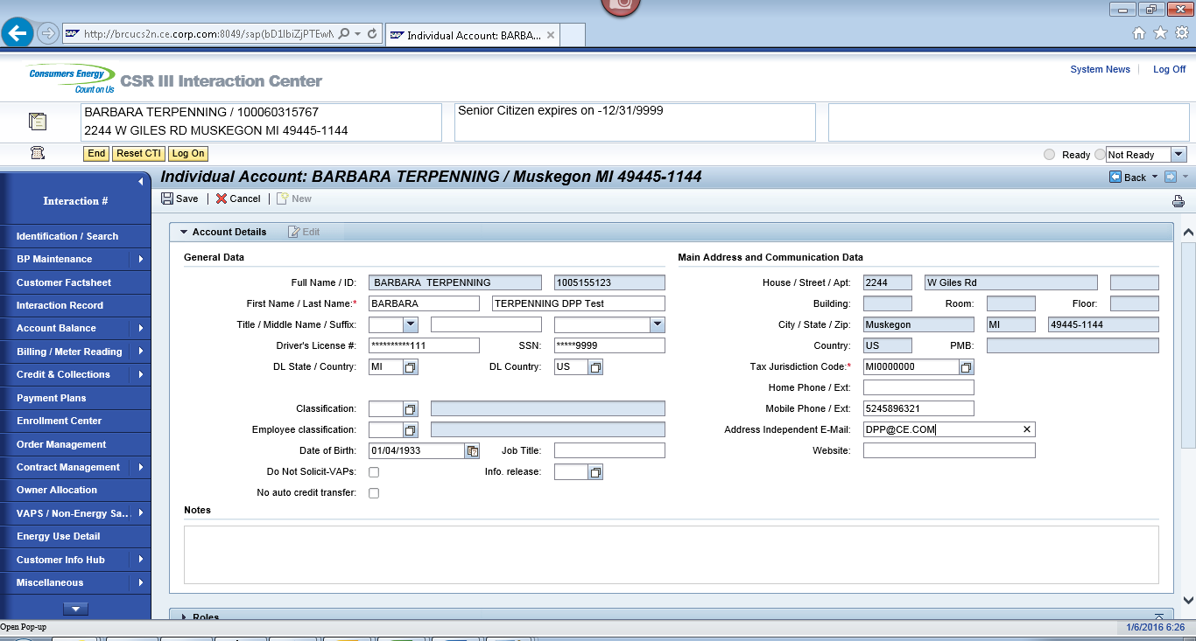
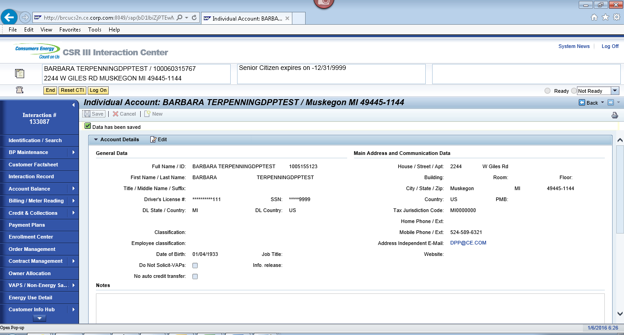

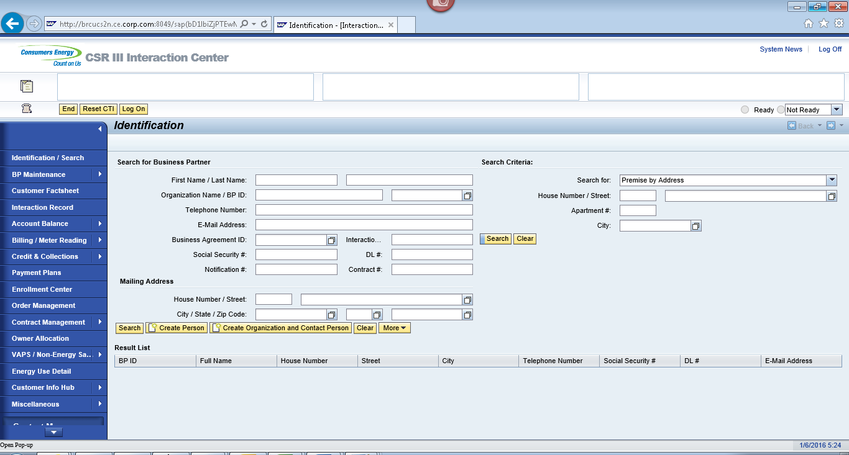
ECC
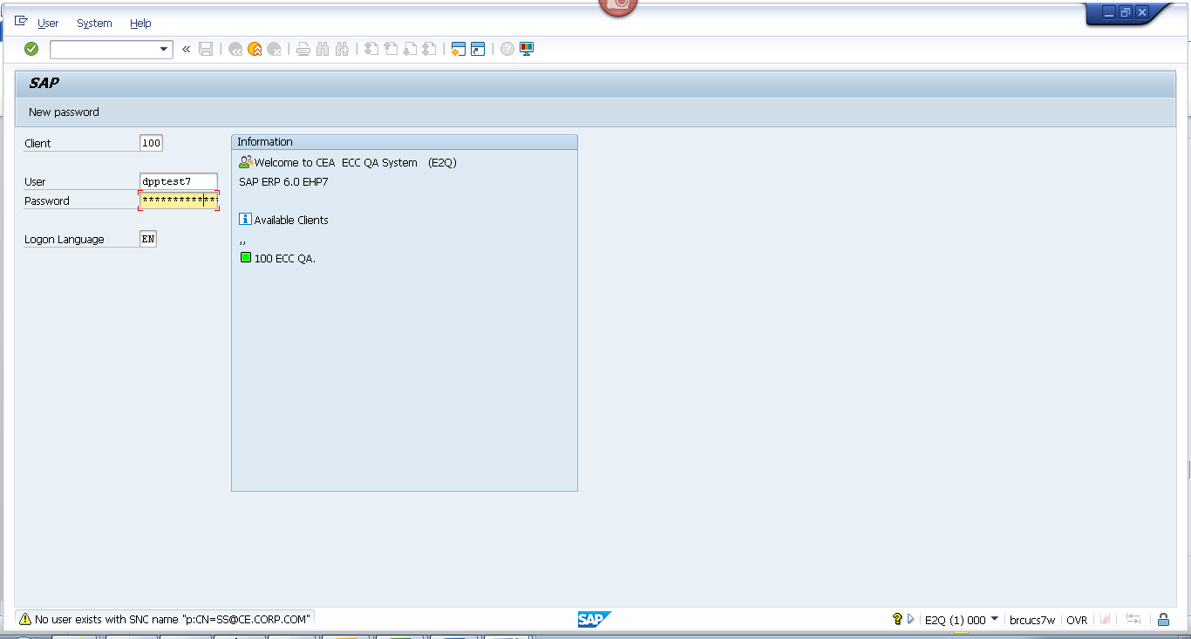
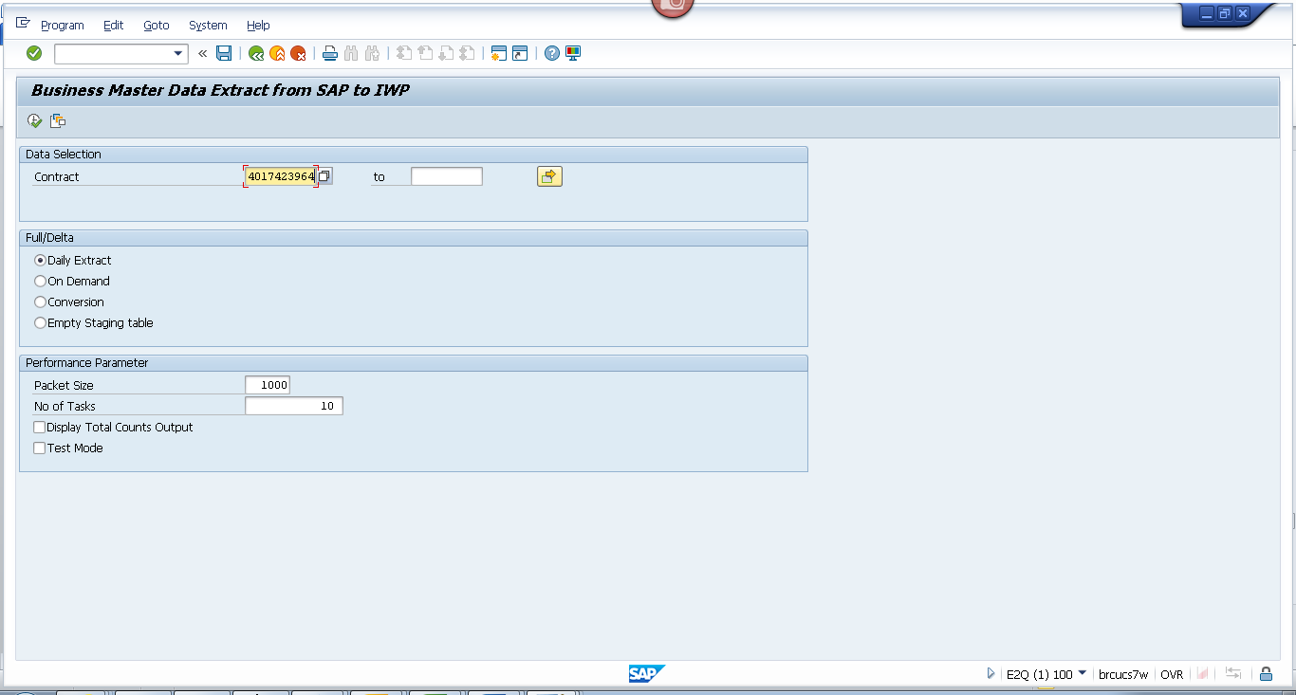
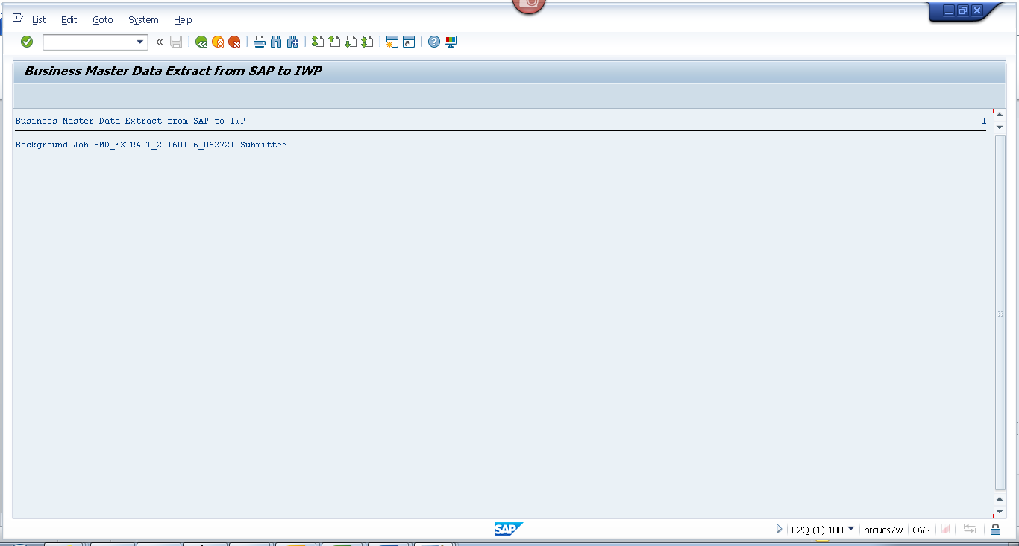

Obj tracking
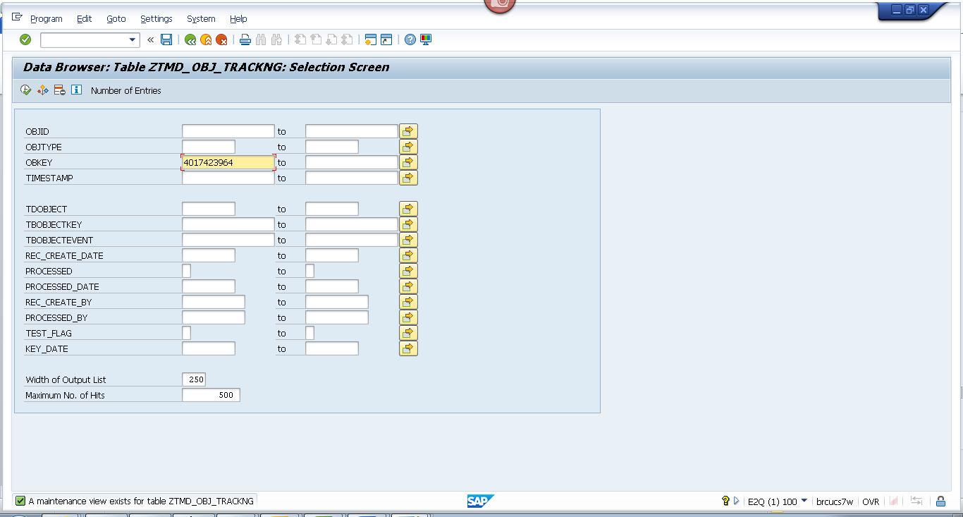
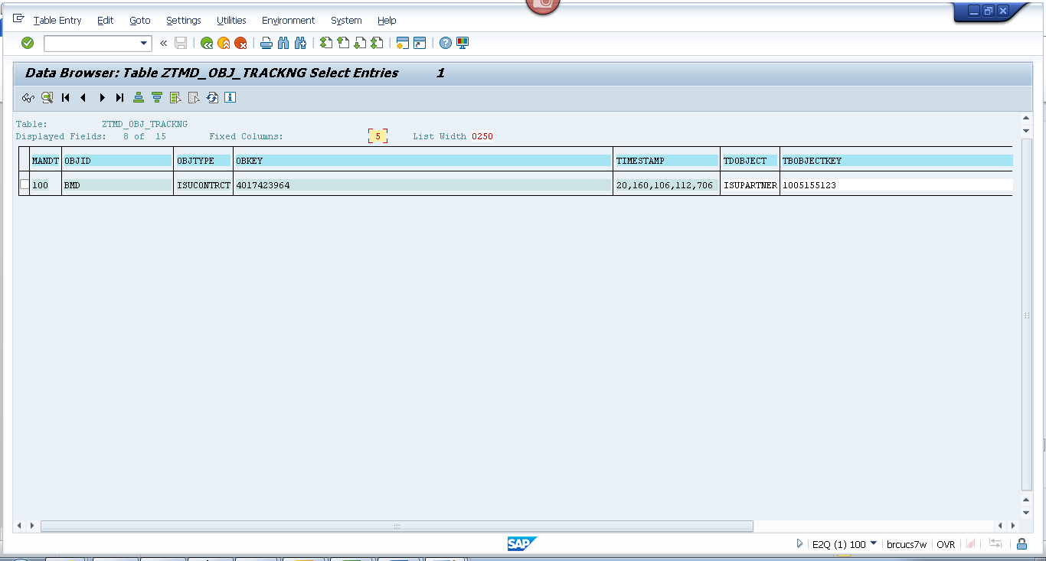
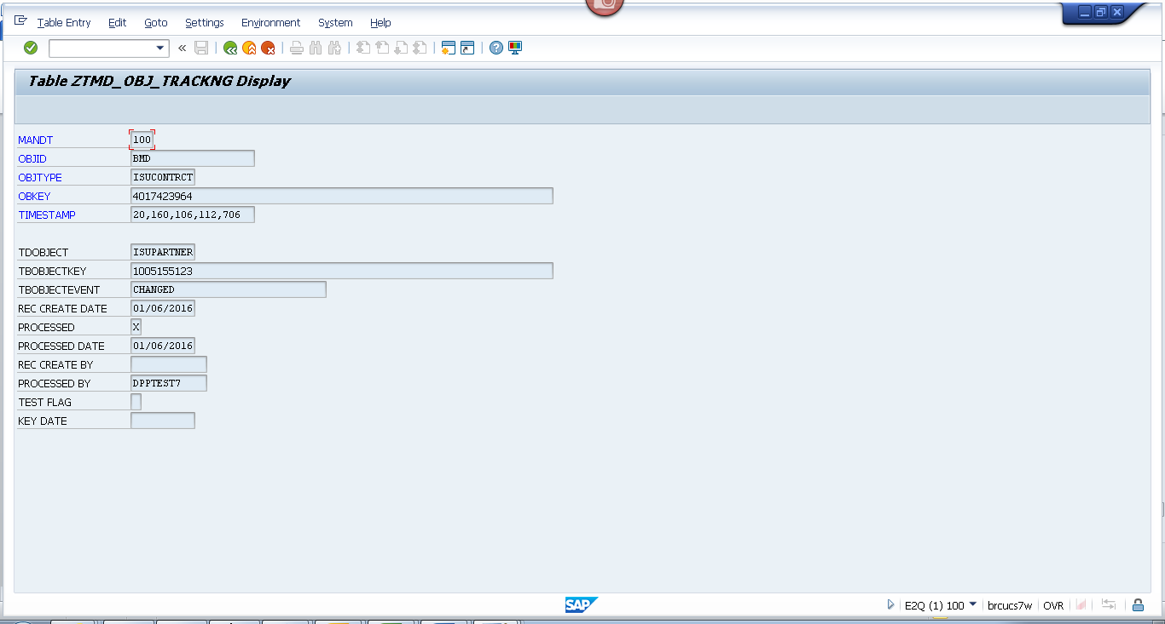

Spool
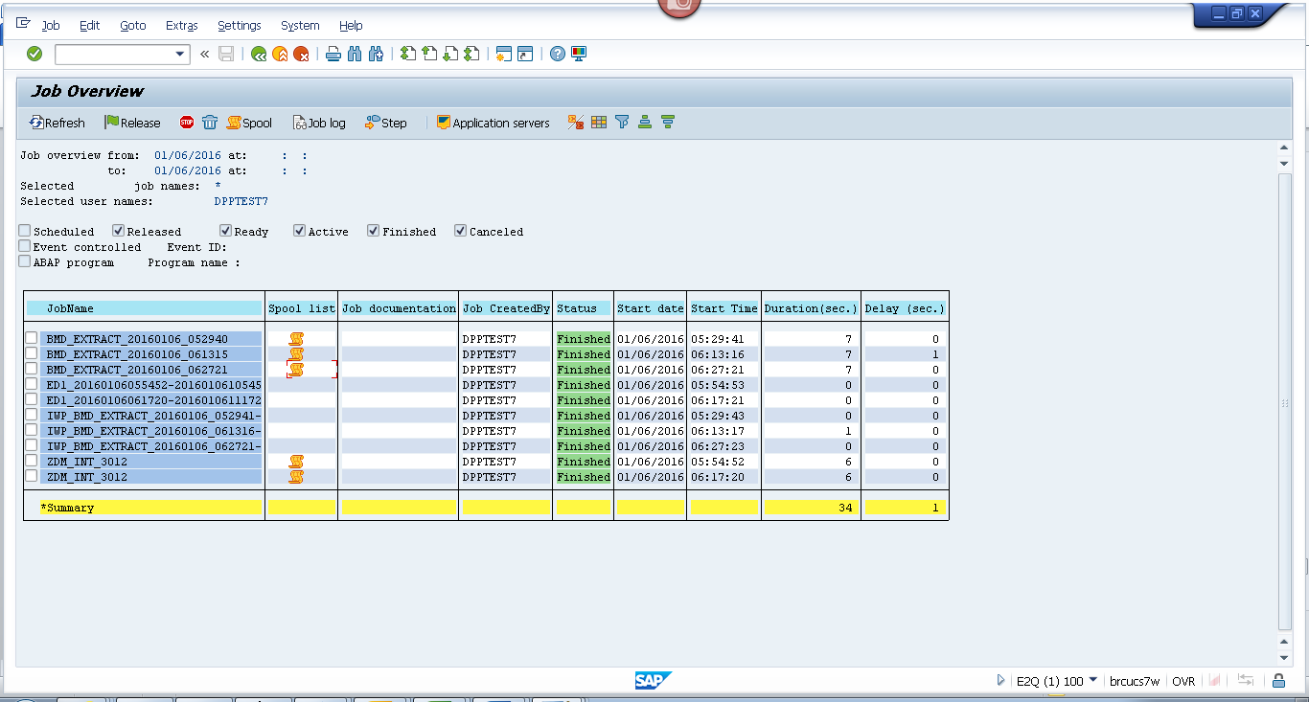
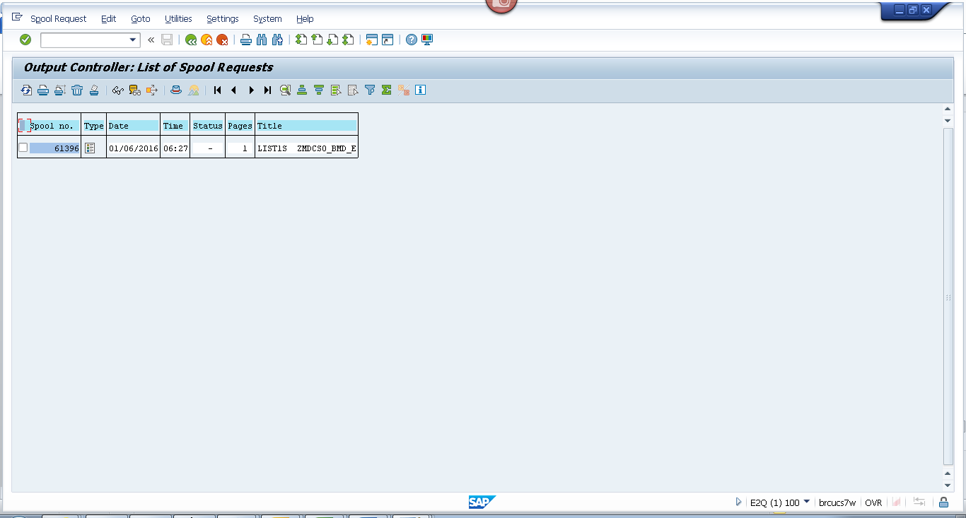
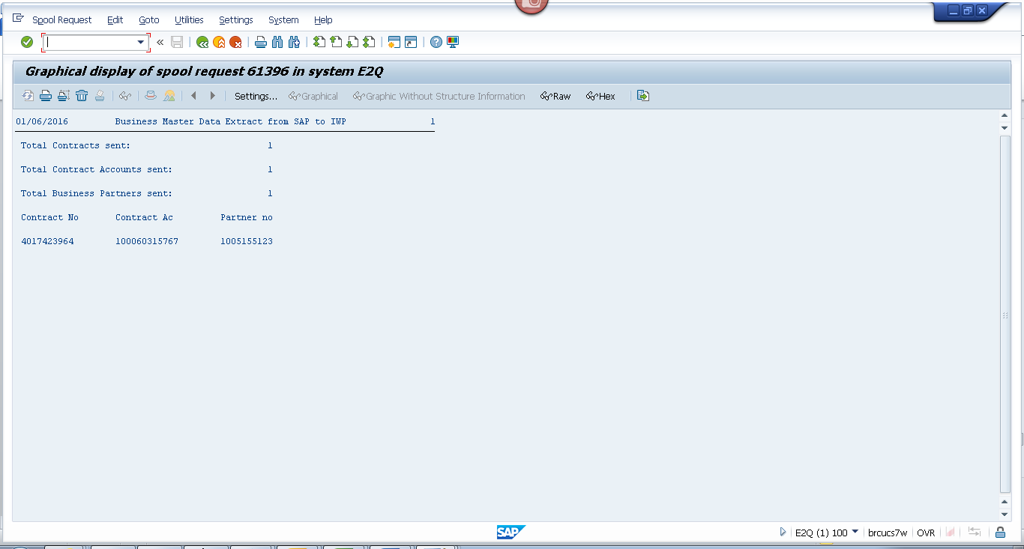

Payload
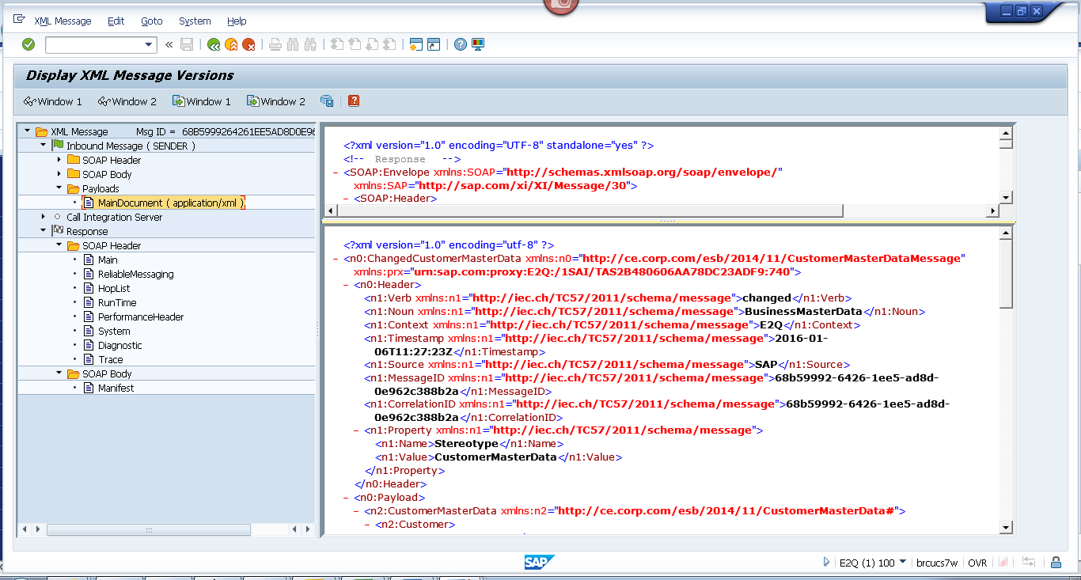
<?xml version="1.0" encoding="utf-8" ?>
- <n0:ChangedCustomerMasterData xmlns:n0="http://ce.corp.com/esb/2014/11/CustomerMasterDataMessage" xmlns:prx="urn:sap.com:proxy:E2Q:/1SAI/TAS2B480606AA78DC23ADF9:740">
- <n0:Header>
<n1:Verb xmlns:n1="http://iec.ch/TC57/2011/schema/message">changed</n1:Verb>
<n1:Noun xmlns:n1="http://iec.ch/TC57/2011/schema/message">BusinessMasterData</n1:Noun>
<n1:Context xmlns:n1="http://iec.ch/TC57/2011/schema/message">E2Q</n1:Context>
<n1:Timestamp xmlns:n1="http://iec.ch/TC57/2011/schema/message">2016-01-06T11:27:23Z</n1:Timestamp>
<n1:Source xmlns:n1="http://iec.ch/TC57/2011/schema/message">SAP</n1:Source>
<n1:MessageID xmlns:n1="http://iec.ch/TC57/2011/schema/message">68b59992-6426-1ee5-ad8d-0e962c388b2a</n1:MessageID>
<n1:CorrelationID xmlns:n1="http://iec.ch/TC57/2011/schema/message">68b59992-6426-1ee5-ad8d-0e962c388b2a</n1:CorrelationID>
- <n1:Property xmlns:n1="http://iec.ch/TC57/2011/schema/message">
<n1:Name>Stereotype</n1:Name>
<n1:Value>CustomerMasterData</n1:Value>
</n1:Property>
</n0:Header>
- <n0:Payload>
- <n2:CustomerMasterData xmlns:n2="http://ce.corp.com/esb/2014/11/CustomerMasterData#">
- <n2:Customer>
<n2:mRID>1005155123</n2:mRID>
<n2:name>BARBARATERPENNINGDPPTEST</n2:name>
- <n2:CustomerAccounts>
<n2:mRID>100060315767</n2:mRID>
<n2:createdDateTime>2011-07-29T04:00:00Z</n2:createdDateTime>
<n2:paperBill>true</n2:paperBill>
<n2:paymentMethod>D</n2:paymentMethod>
<n2:paymentTerm>CE21</n2:paymentTerm>
<n2:type>RES</n2:type>
- <n2:CustomerAgreements>
<n2:mRID>4017423964</n2:mRID>
<n2:accountDeterminationID>RT</n2:accountDeterminationID>
<n2:createdDateTime>2011-07-29T04:00:00Z</n2:createdDateTime>
<n2:division>ELECTRIC</n2:division>
<n2:rateCategory>RS_1000</n2:rateCategory>
<n2:startMonth>00</n2:startMonth>
+ <n2:Installation>

- <n2:ServiceLocations>
- <n2:UsagePoints>
<n2:mRID>6001373962</n2:mRID>
</n2:UsagePoints>
</n2:ServiceLocations>
- <n2:validityInterval>
<n2:end>9999-12-31T23:59:59Z</n2:end>
<n2:start>2011-07-29T00:00:00Z</n2:start>
</n2:validityInterval>
</n2:CustomerAgreements>
</n2:CustomerAccounts>
- <n2:Indicators>
<n2:endDate>9999-12-31T23:59:59Z</n2:endDate>
<n2:startDate>2011-07-29T00:00:00Z</n2:startDate>
<n2:type>SENIOR</n2:type>
<n2:value>true</n2:value>
</n2:Indicators>
- <n2:Indicators>
<n2:type>DPP EXCLUSION</n2:type>
</n2:Indicators>
- <n2:Indicators>
<n2:type>DO NOT MARKET</n2:type>
</n2:Indicators>
- <n2:MainAddress>
- <n2:streetDetail>
<n2:buildingName>0030222999</n2:buildingName>
<n2:name>W Giles Rd</n2:name>
<n2:number>2244</n2:number>
</n2:streetDetail>
- <n2:townDetail>
<n2:code>49445-1144</n2:code>
<n2:country>US</n2:country>
<n2:name>Muskegon</n2:name>
<n2:stateOrProvince>MI</n2:stateOrProvince>
</n2:townDetail>
</n2:MainAddress>
- <n2:Persons>
<n2:firstName>BARBARA</n2:firstName>
<n2:lastName>TERPENNINGDPPTEST</n2:lastName>
- <n2:electronicAddress>
<n2:email1>DPP@CE.COM</n2:email1>
</n2:electronicAddress>
- <n2:landlinePhone>
<n2:localNumber>231-744-0164-</n2:localNumber>
</n2:landlinePhone>
- <n2:mobilePhone>
<n2:localNumber>524-589-6321</n2:localNumber>
</n2:mobilePhone>
</n2:Persons>
</n2:Customer>
</n2:CustomerMasterData>
</n0:Payload>
</n0:ChangedCustomerMasterData>

